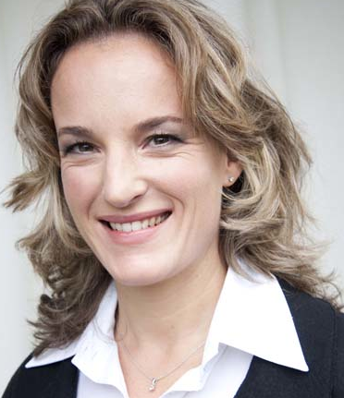
CURRICULUM VITAE

Drs. Susan (Sue) der Kinderen

Da Costastraat 115 1053ZK Amsterdam • +31 (0)651879234

info@clearyourhead.nl www.clearyourhead.nl

I was born and raised in South Africa and have lived, with my husband and two children, in the Netherlands since 1999. I have always shown enthusiasm and affinity for working with diverse groups of people as is evident in my studies, training, and work experience detailed below. My current work passions include promoting mental capital through wellbeing interventions in the workplace and exploring the role of work as a source of happiness and good functioning. I am fluent in Dutch and English.

PROFESSIONAL EXPERIENCE

Shared Ambition Psychologist - Franchisee 2008 - Current
Under the auspices of Shared Ambition, as part of a team of psychologists located throughout The Netherlands, I provide psychological intervention and support to individuals and advise to management regarding the optimization of employee’s wellbeing and performance. Contact with individuals ranges from coaching to psychological intervention and include, for example, performance improvement, the acquisition of new competencies, facilitating changes within the work (and private) context.

Private Practice Psychologist & Coach 2008 – Current
Using an eclectic mix of methods, tools and techniques I collaborate with my clients to increase their effectiveness and build resilience through insight, reflection and solution building. When applicable this can include the use of questionnaires or assessment tools. Problem areas are broad, covering the spectrum of individual functioning in life areas including private life, work, relationships, social contacts and health and wellbeing. I also offer customized group facilitations, team coaching or workshops. Past workshops have included stress awareness; building resilience in individuals and teams; managing change and creating a plan for a “preferred future”. Clients have included Shell, Nike, AHK, Rabobank. Please refer to www.clearyourhead.nl for more information.

ACCESS Volunteer for Counselling Service Network 2008-2012
As a member of an international group of counselors (ranging from social workers to clinical psychologists and therapists) Access offers a referral and counseling service to the expat community.

Mensenwerk b.v. Employee Counsellor & Coach 2002-2008
Via Mensenwerk I worked at various Shell locations in the Netherlands and for the Tweede Kamer der Staten Generaal as an Employee Counsellor/Coach. Primary tasks included individual guidance on work-related and private problems with the necessary referrals and follow-up. Interventions on group level included focus groups and workshops on topics such as stress awareness workshops and coping with change. I worked in a multi-disciplinary team with a HR, company doctor, occupational nurse and physiotherapist. On an organizational level there was regular participation in Social Medical Team discussions, active absenteeism management as well as participation in HR or Health Services projects for the development of new policies (e.g. life-stage-based HR policy, diversity, work life balance).

Accenture b.v. HR Advisor 2000 - 2002
I was responsible for a population of about 200 people regarding general HR matters including advice, project placements and career management. Projects included recognizing and addressing RSI within the company; the implementation a new absenteeism management policy; Mental Coaching (set up workshop for management on RSI and burnout) and a workshop for “among out best leaders” using the MBTI.

EDUCATION, TRAINING & AFFILIATIONS

I have a master’s degree in Counselling psychology from the University of Stellenbosch, South Africa, which included post-academic training and a supervised internship resulting in registration on the Health Professionals Council of South Africa as a registered psychologist in 2000. In the Netherlands I followed this with an intensive coaching training (Leergang Coaching) at Proeducation, Amsterdam and a Masterclass Oplossingsgericht Management & Coaching at the Korzybski Instituut and Saxion Hogeschool. Other courses: Narrative Coaching; Managing stress & Burnout (RINO); NLP practitioner; MBTI; Mindfulness;

I’m affiliated with the following professional organisations: NIP (A&O registerpsycholoog); ABvC and Erkend Coach St!R
Please contact me should you require any further information or references.

